Queries: World (Practice)

Martisha Owens

1. Get the countries with a Surface Area below 501 and a Population greater than 100,000? Include the country name, surface area, and population in your results.

* Select Name, Surface_area, Population

From Countries

where Surface_area < 501 and Population > 100000;

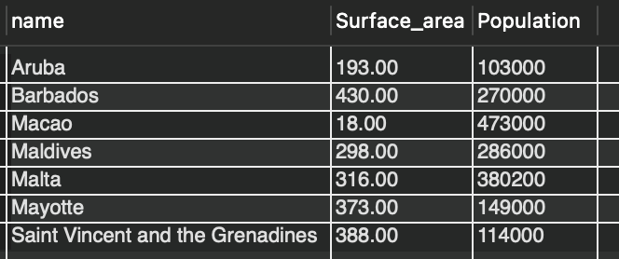

1. Get countries with only a Constitutional Monarchy with a capital greater than 200 and a life expectancy greater than 75 years? Include the country name, form of government, and capital in your results.

* Select Name, Government_form, Capital

From Countries

where government_form = 'Constitutional Monarchy' and capital > 200 and life_expectancy > 75;

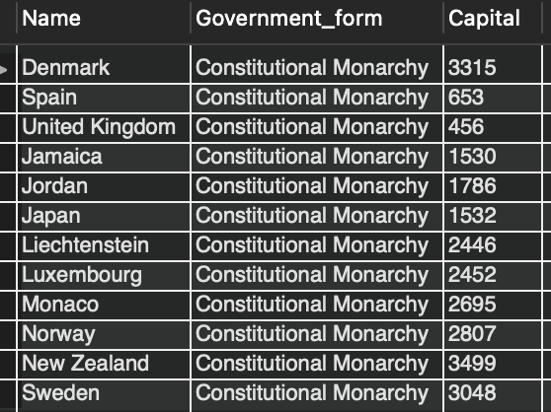

1. Summarize the number of countries in each region? Should display the name of the region and the number of countries. Also, arrange the result by the number of countries in desc order.
   * Select Region, Count(name) As Country_Total

From Countries

Group By Region

Order By Country_Total Desc;

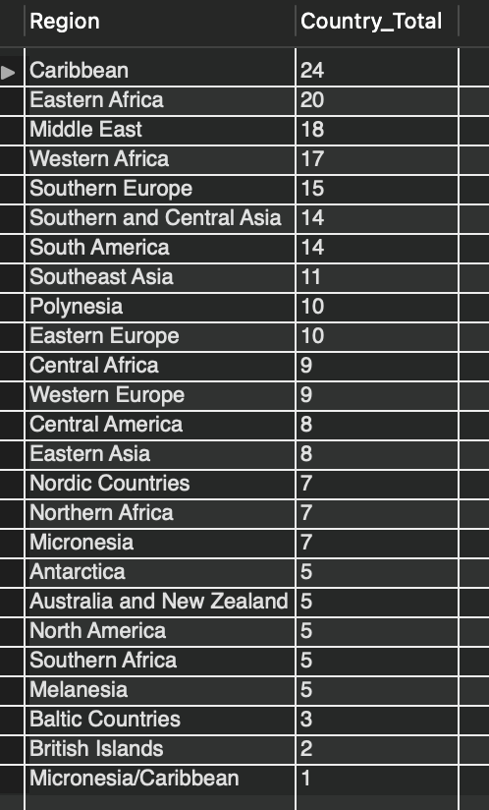

1. Get all the countries that speak Slovene? Your query should return the name of the country, language, and language percentage. Your query should arrange the result by language percentage in descending order.

* Select c.name, l.language, l.percentage

From countries c

Join languages l

On c.id = l.country_id

Where l.language = 'Slovene';

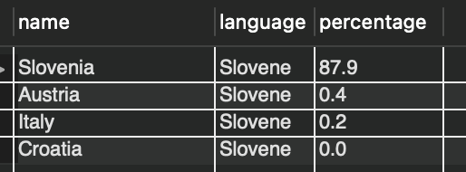

1. Display the total number of cities for each country? Your query should return the name of the country and the total number of cities. Your query should arrange the result by the number of cities in descending order.

* Select c.name, count(s.name) As City_total

From countries c

Join cities s

On c.id = s.country_id

Group By c.name

Order by City_total desc;

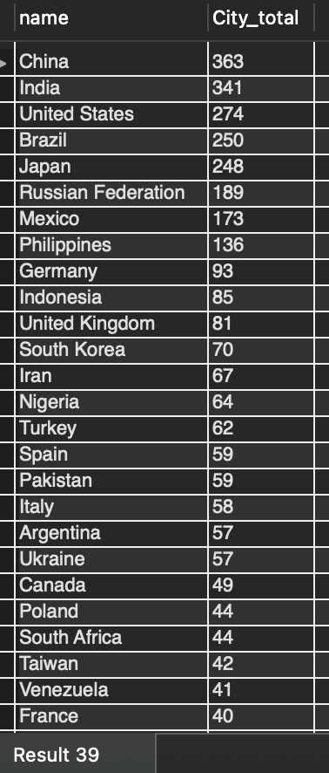

1. Get all the cities in Mexico with a population of greater than 500,000? Your query should arrange the result by population in descending order.

* Select c.name As Country, s.name As City, s.population

From countries c

Join cities s

On c.id = s.country_id

Where c.name = 'Mexico' and s.population > 500000

order by population desc;

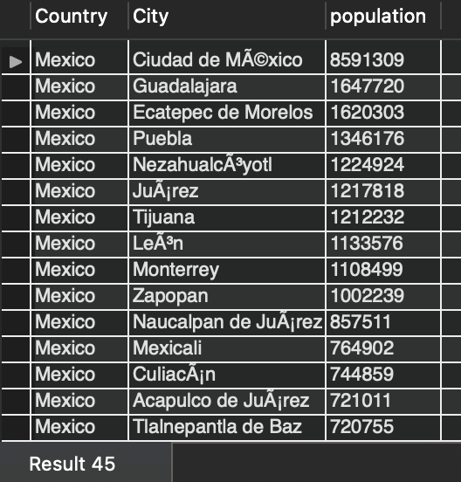

1. What query would you run to get all languages in each country with a percentage greater than 89%? Include the country name, language, and percentage. Your query should arrange the result by percentage in descending order.

* Select c.name as Country, l.language, l.percentage

From countries c

Join languages l

On c.id = l.country_id

Where percentage > 89

Order By percentage Desc;

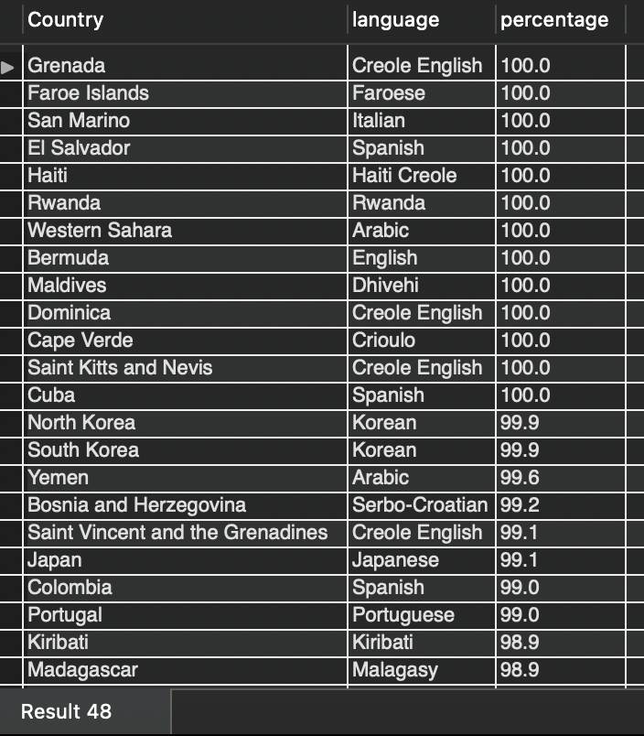

1. What query would you run to get all the cities of Argentina inside the Buenos Aires district and have a population greater than 500,000? The query should return the Country Name, City Name, District, and Population.

* Select c.name As Country, s.name As City, s.district, s.population

From countries c

Join cities s

On c.id = s.country_id

Where c.name = 'Argentina' and s.district = 'Buenos Aires' and s.population > 500000

order by population desc;

